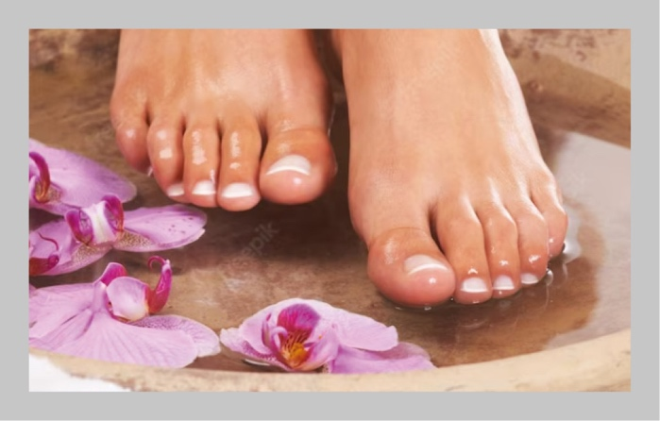

ENJOY a fun **Pamper and Foot Spa Party**

with friends, family or colleagues.

Relax while we pamper your feet.

Experience some of the best-selling Rooibos-based products.

Presented by **[Name]   
[Contact #]**

**[Date]**

[Time]

[Venue]

[RSVP]

Foot Spa Party

FREE

Mini Pamper &